EXPERIMENT 6
DML COMMANDS (COLLEGE SCHEMA)

Aim:
- Insert 5 instances into the tables created in experiment 6.
- Display the tables.
- Add attribute course to student table then insert values.
- Use update to set course for students.
- Delete an attribute.

QUERIES:

- Insert 5 instances into the tables created in experiment 6.
- Display the tables.
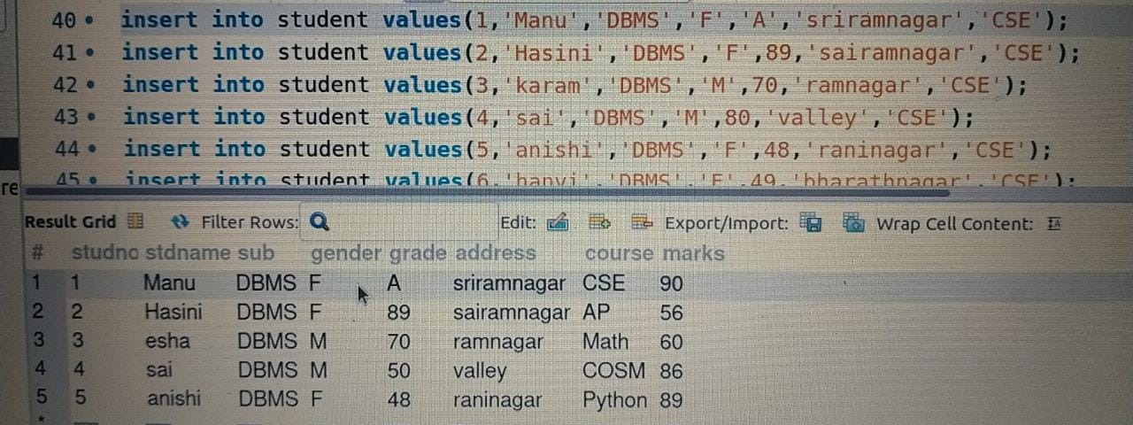
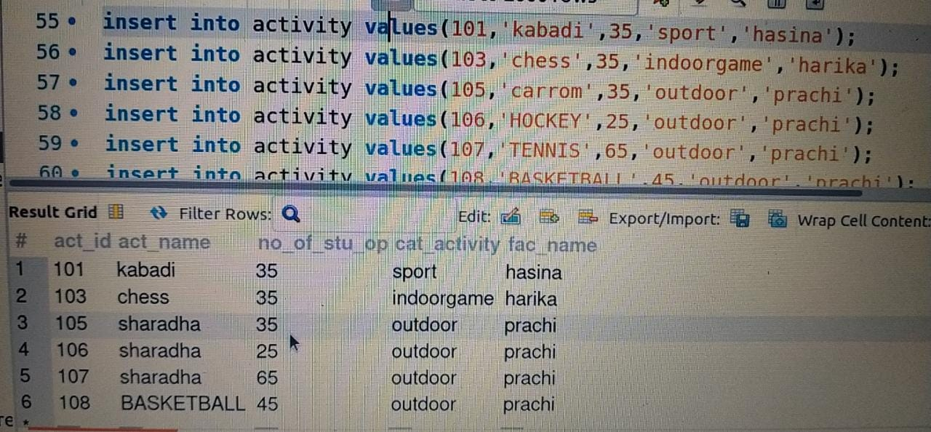
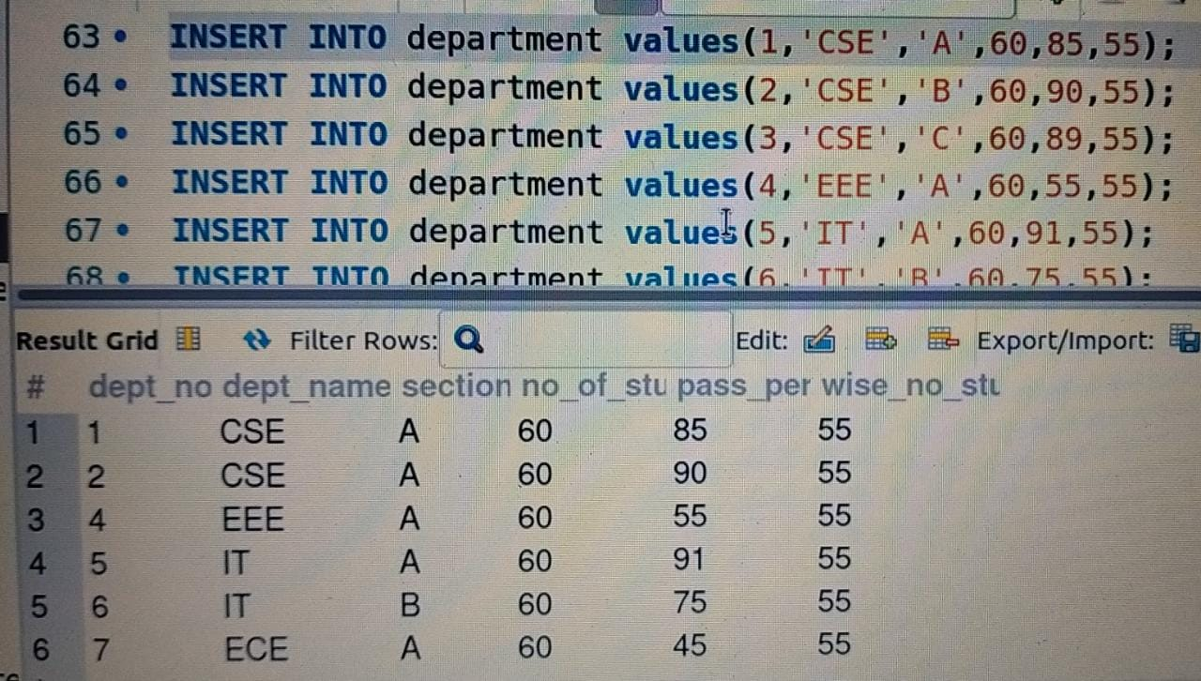

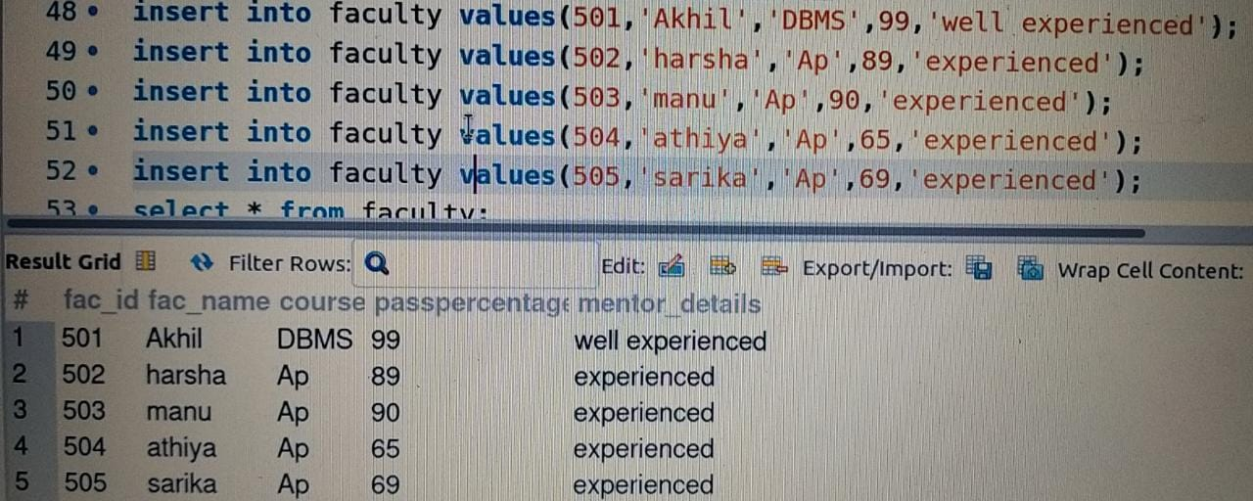

- Add attribute course to student table then insert values.

- Use update to set course for students.
- Delete an attribute.


